Project Planning Phase

Project Planning Template (Product Backlog, Sprint Planning, Stories, Story points)

|  |  |
| --- | --- |
| Team ID | PNT2022TMID12796 |
| Project Name | Industry - Specific Intelligent Fire Management System |
| Maximum Marks | 8 Marks |

Product Backlog, Sprint Schedule, and Estimation (4 Marks):

|  |  |  |  |  |  |  |
| --- | --- | --- | --- | --- | --- | --- |
| **Sprint** | **Functional Requirement (Epic)** | **User Story Number** | **User Story / Task** | **Story Points** | **Priority** | **Team Members** |
| Sprint-1 | Registration | USN-1 | As a user, you can register in the application by entering your email address, password, and confirming the password. | 2 | High | Mukesh Kumar A |
| Sprint-2 | Registration | USN-2 | As a user, you will receive a confirmation email after registering in the application. | 3 | Medium | Vigneshwar R |
| Sprint-3 | Registration | USN-3 | As a user, you can register in the application via Facebook | 1 | Low | Subaash G |

|  |  |  |  |  |  |  |
| --- | --- | --- | --- | --- | --- | --- |
| Sprint-2 | Registration | USN-4 | As a user, you can register in the application via Gmail. | 1 | High | Vigneshwar R |
| Sprint-4 | Login | USN-5 | As a user, you can login to the application by entering your email and password. | 5 | High | Jayanthan C |
| Sprint-1 | Dashboard | USN-6 | As a user, you can receive notifications. | 1 | Medium | Subaash G |
| Sprint-3 | Testing & Deployment Phase-I | USN-7 | System performance testing. Use for emergencies. | 8 | High | Mukesh kumar A |
| Sprint-3 | Testing & Deployment Phase-I | USN-8 | Make sure the system detects fire and gas correctly. Additionally, the user will be notified. | 2 | High | Vigneshwar R |
| Sprint-1 | Deployment Phase-II &Model Improvement | USN-9 | By providing an IOT-based industry-specific fire control system, the system can be checked and used 24/7. | 1 | Low | Mukesh kumar A |
| Sprint-2 | Verification | USN-10 | Administrators have full visibility of submitted applications. | 5 | High | Subaash G |
| Sprint-3 | Approval | USN-11 | After completion, the customer will be provided with new bank access data. | 2 | High | Jayanthan C |

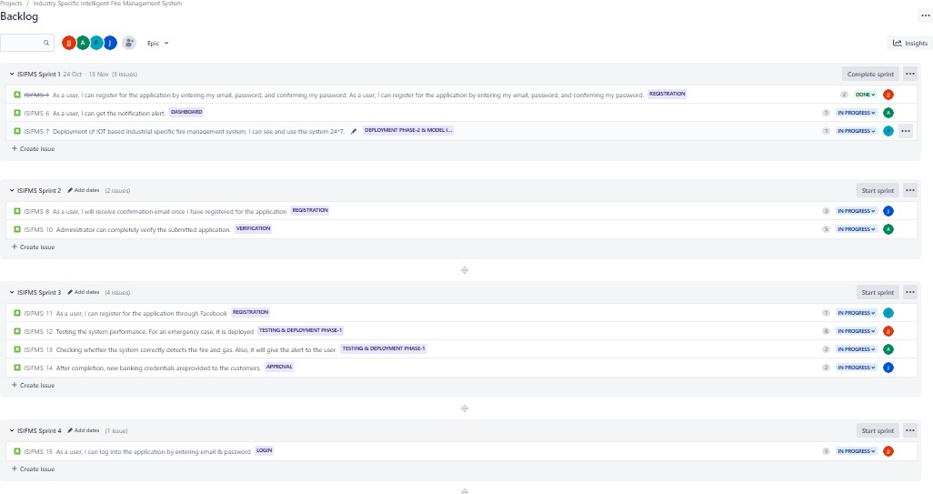

Project Tracker, Velocity & Burndown Chart: (4 Marks)

|  |  |  |  |  |  |  |
| --- | --- | --- | --- | --- | --- | --- |
| **Sprint** | **Total Story Points** | **Duration** | **Sprint Start Date** | **Sprint End Date (Planned)** | **Story Points Completed (as on Planned End**  **Date)** | **Sprint Release Date(Actual)** |
| Sprint-1 | 20 | 6 Days | 24 Oct 2022 | 29 Oct 2022 | 20 | 29 Oct 2022 |
| Sprint-2 | 20 | 6 Days | 31 Oct 2022 | 05 Nov 2022 | 20 | 05 Nov 2022 |
| Sprint-3 | 20 | 6 Days | 07 Nov 2022 | 12 Nov 2022 | 20 | 12 Nov 2022 |
| Sprint-4 | 20 | 6 Days | 14 Nov 2022 | 19 Nov 2022 | 20 | 19 Nov 2022 |

Velocity:

The team’s average velocity (AV) per iteration unit (story points per day)

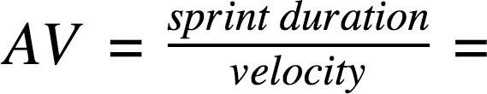

Burndown Chart:

